Name: Arshiya Tabassum A

Superset ID: 6424209

**WEEK 1**

**Data Structures and Algorithm**

**Module 2**

Exercise 1: Inventory Management System

Scenario: You are developing an inventory management system for a warehouse. Efficient data storage and retrieval are crucial.

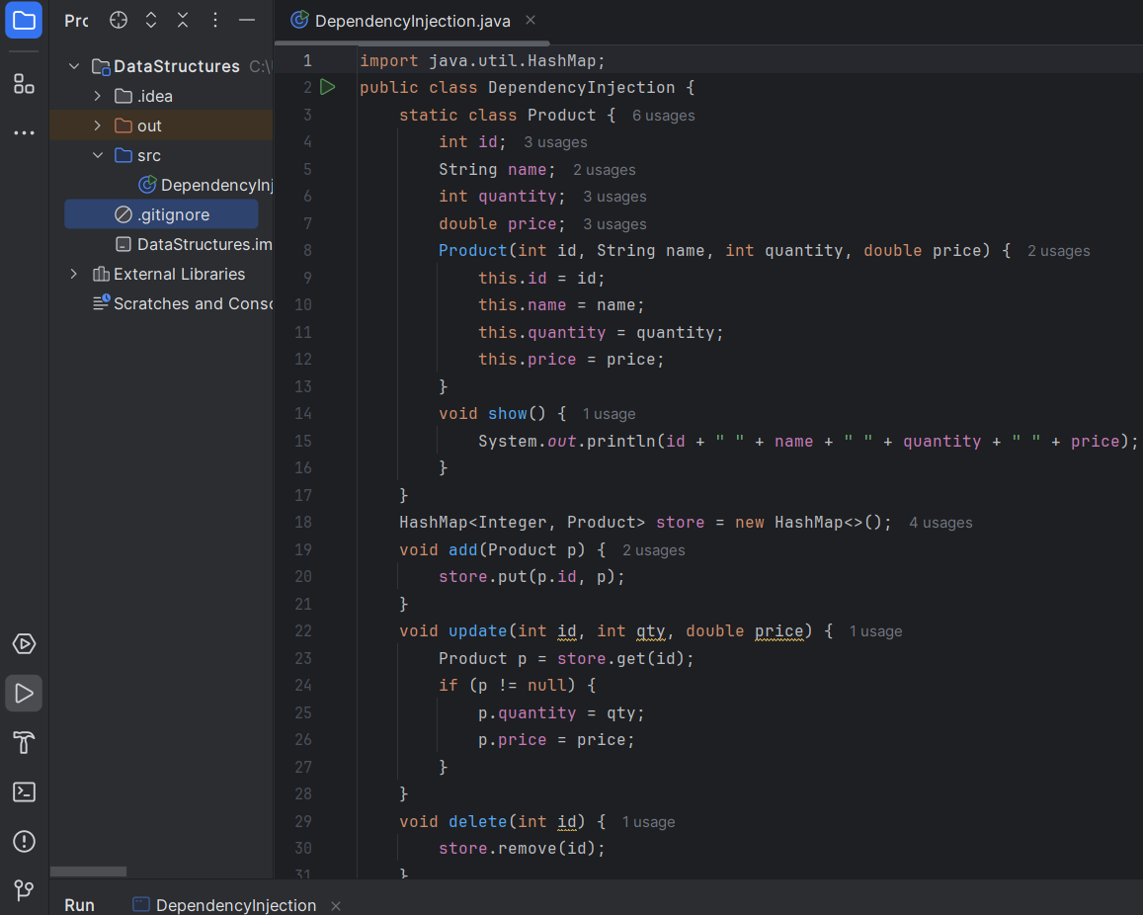

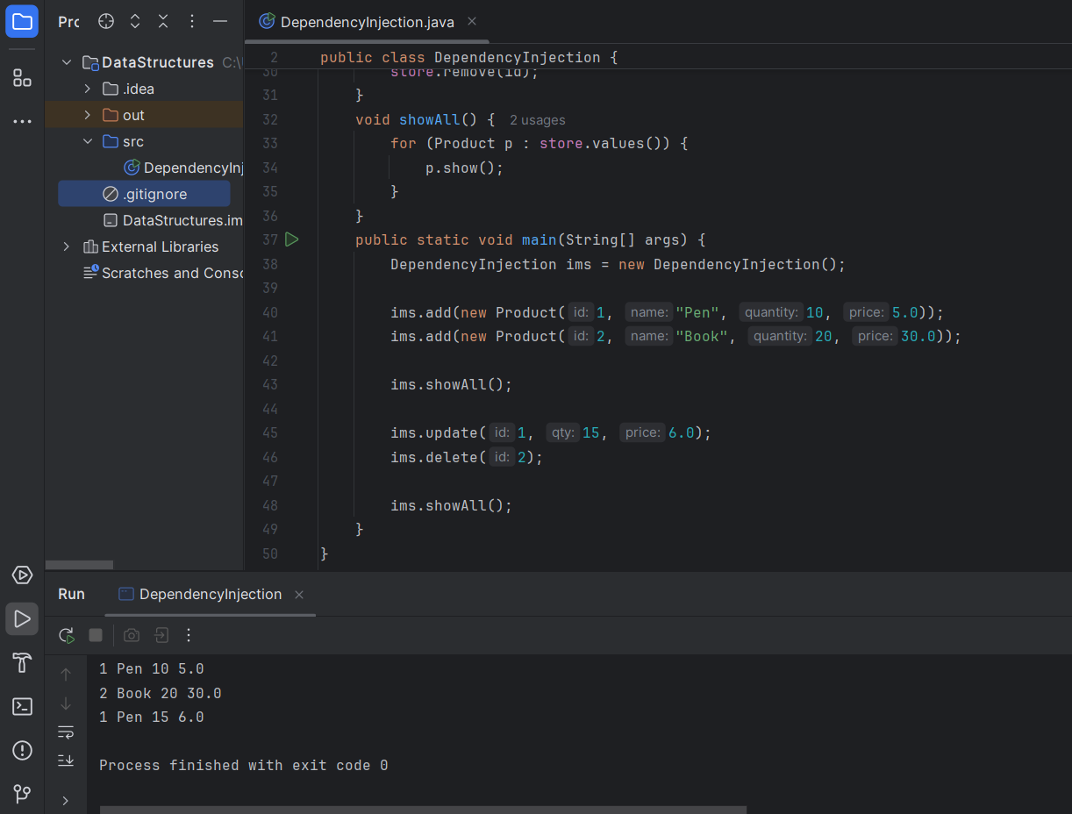

Exercise 2: E-commerce Platform Search Function

Scenario: You are working on the search functionality of an e-commerce platform. The search needs to be optimized for fast performance.

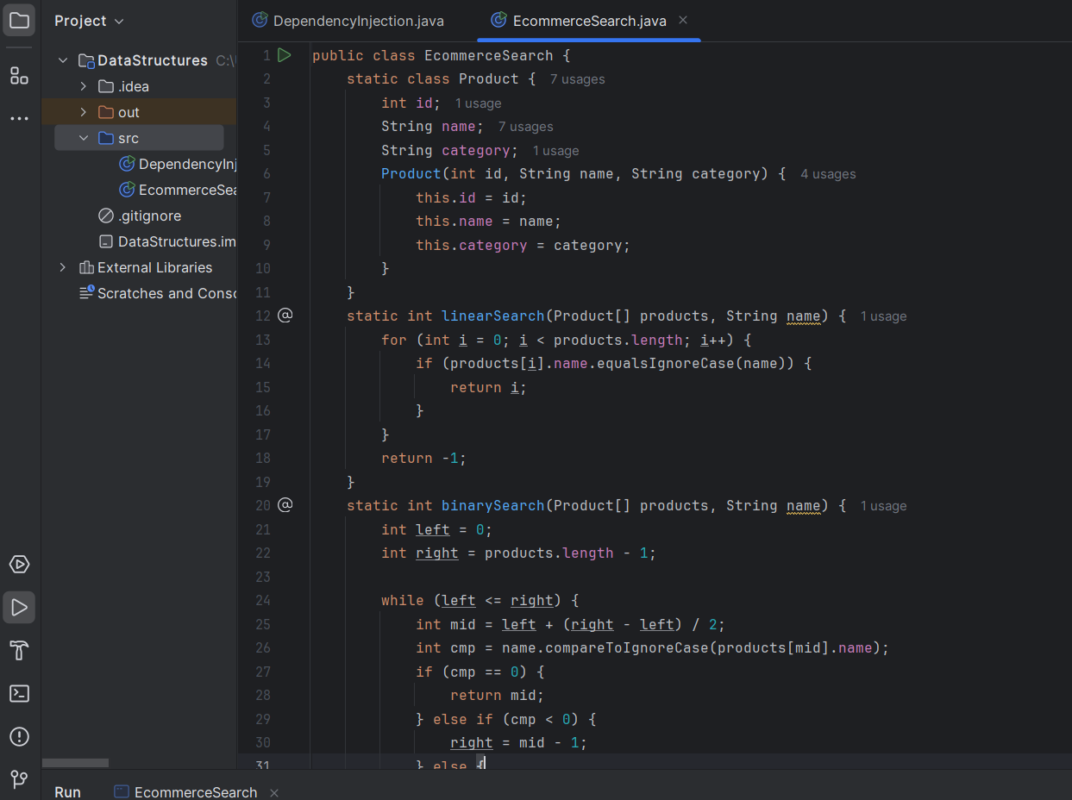

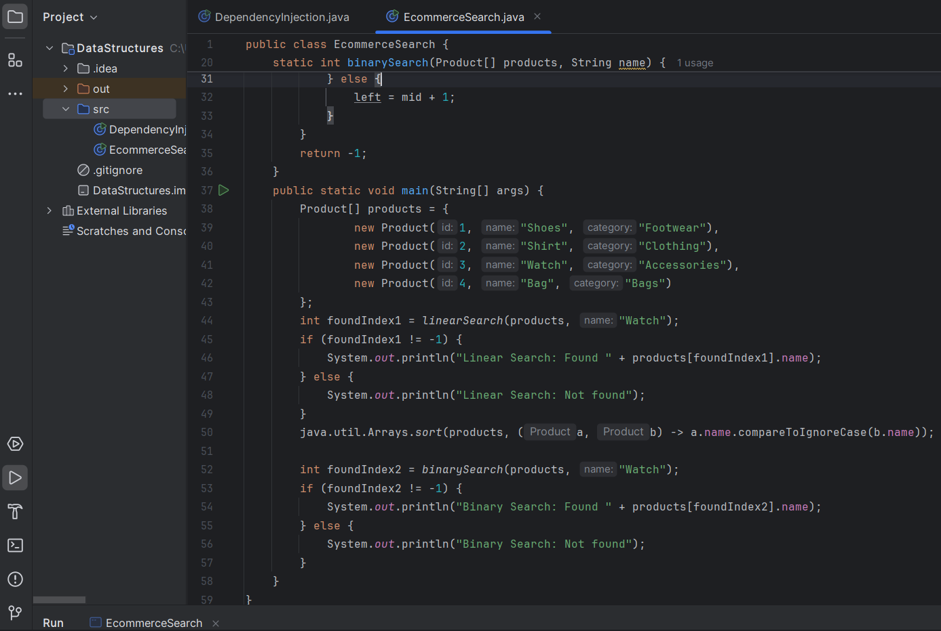

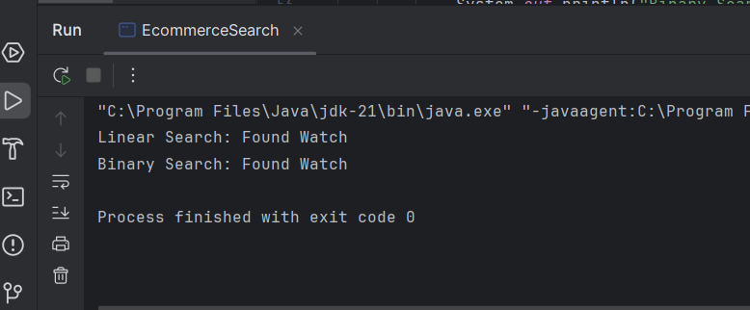

Exercise 3: Sorting Customer Orders

Scenario: You are tasked with sorting customer orders by their total price on an e-commerce platform. This helps in prioritizing high-value orders.

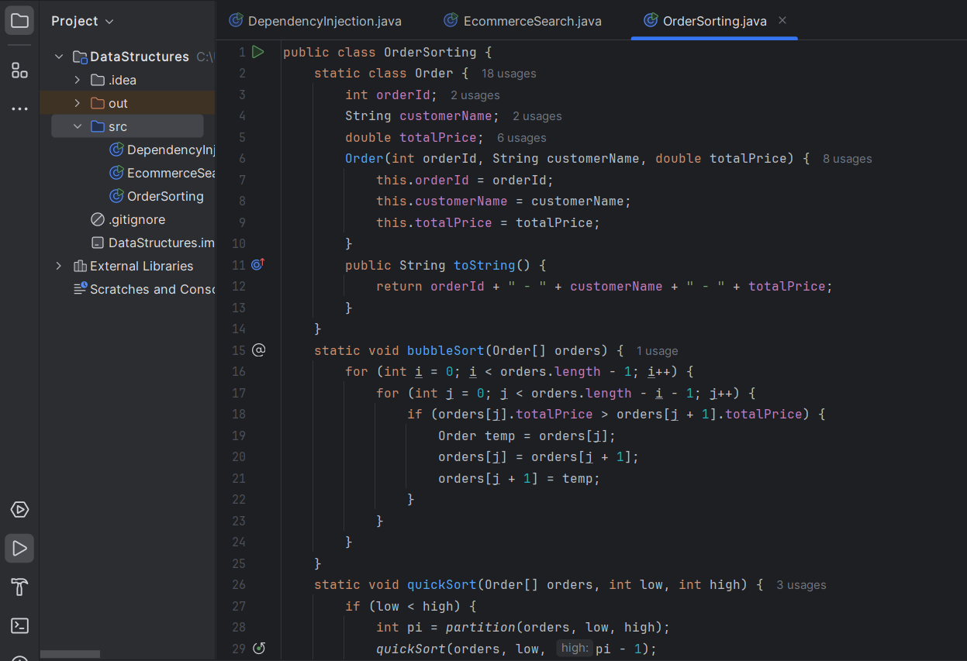

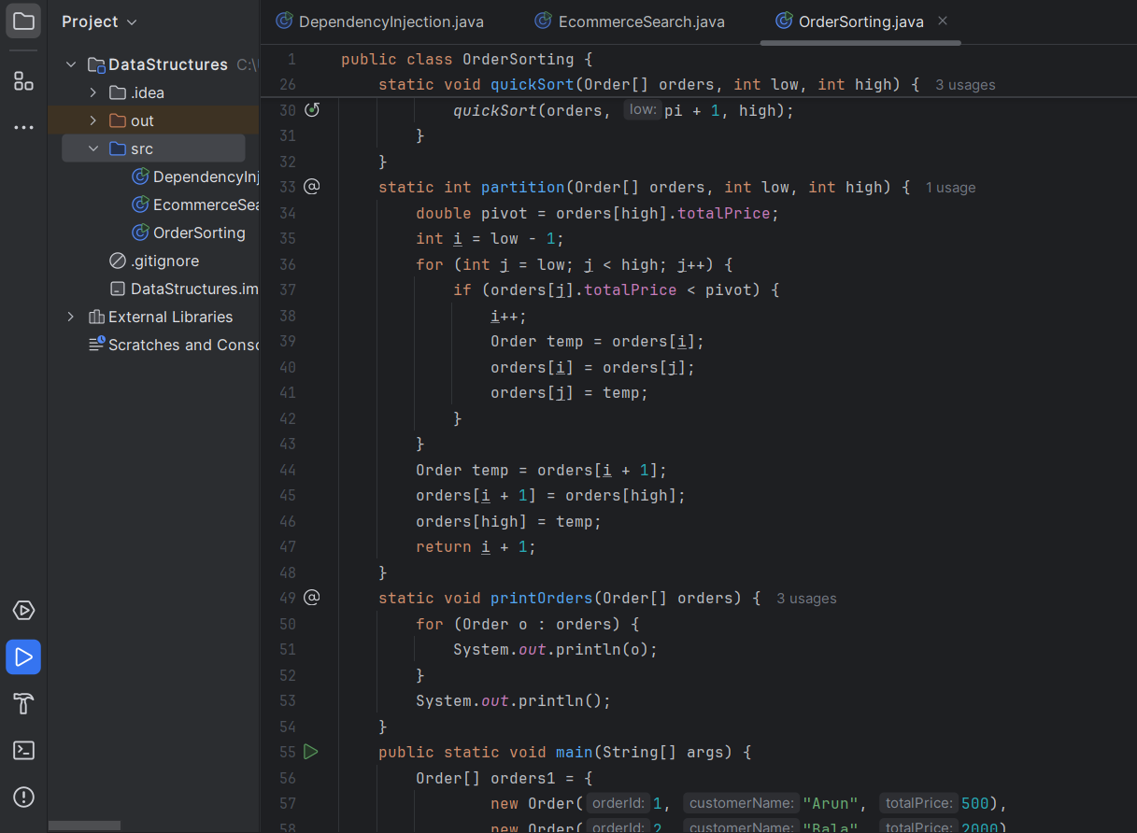

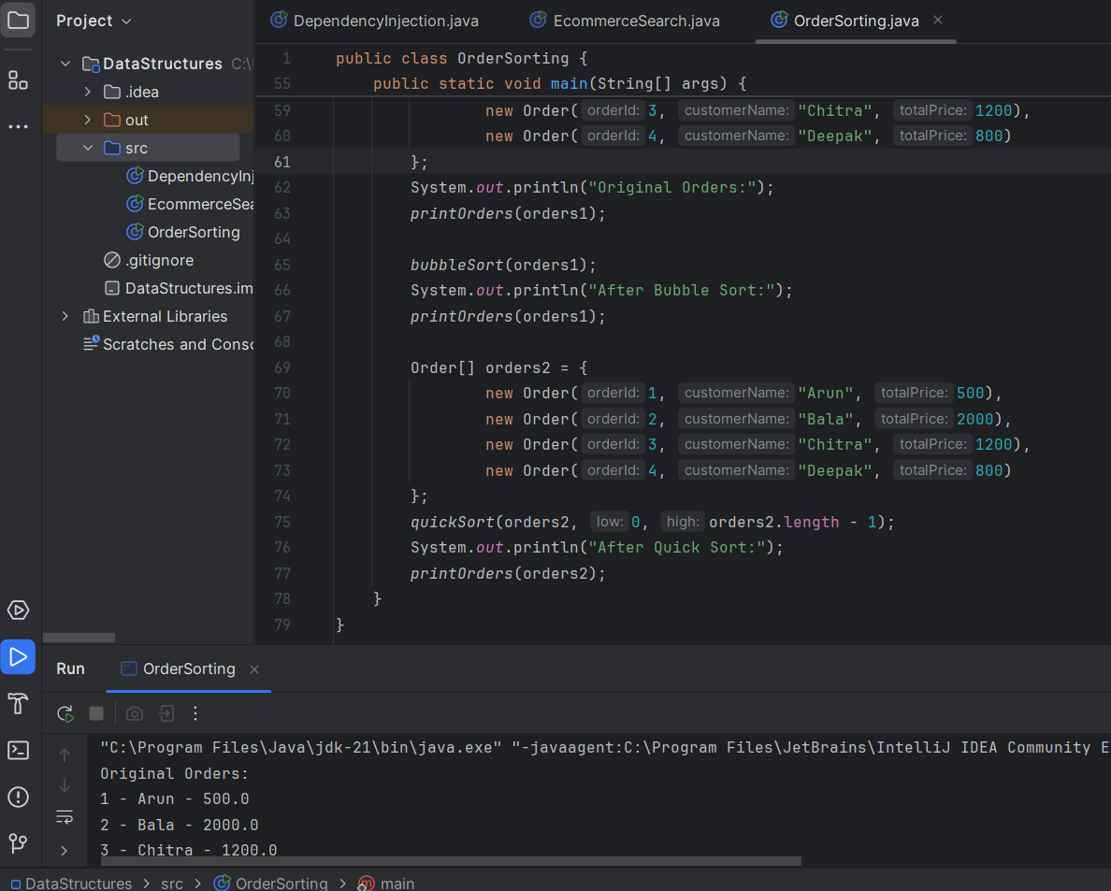

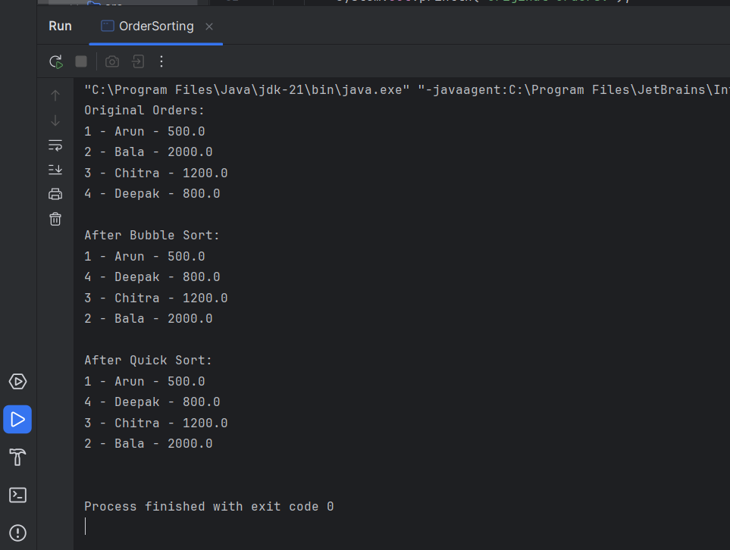\

Exercise 4: Employee Management System

Scenario: You are developing an employee management system for a company. Efficiently managing employee records is crucial.

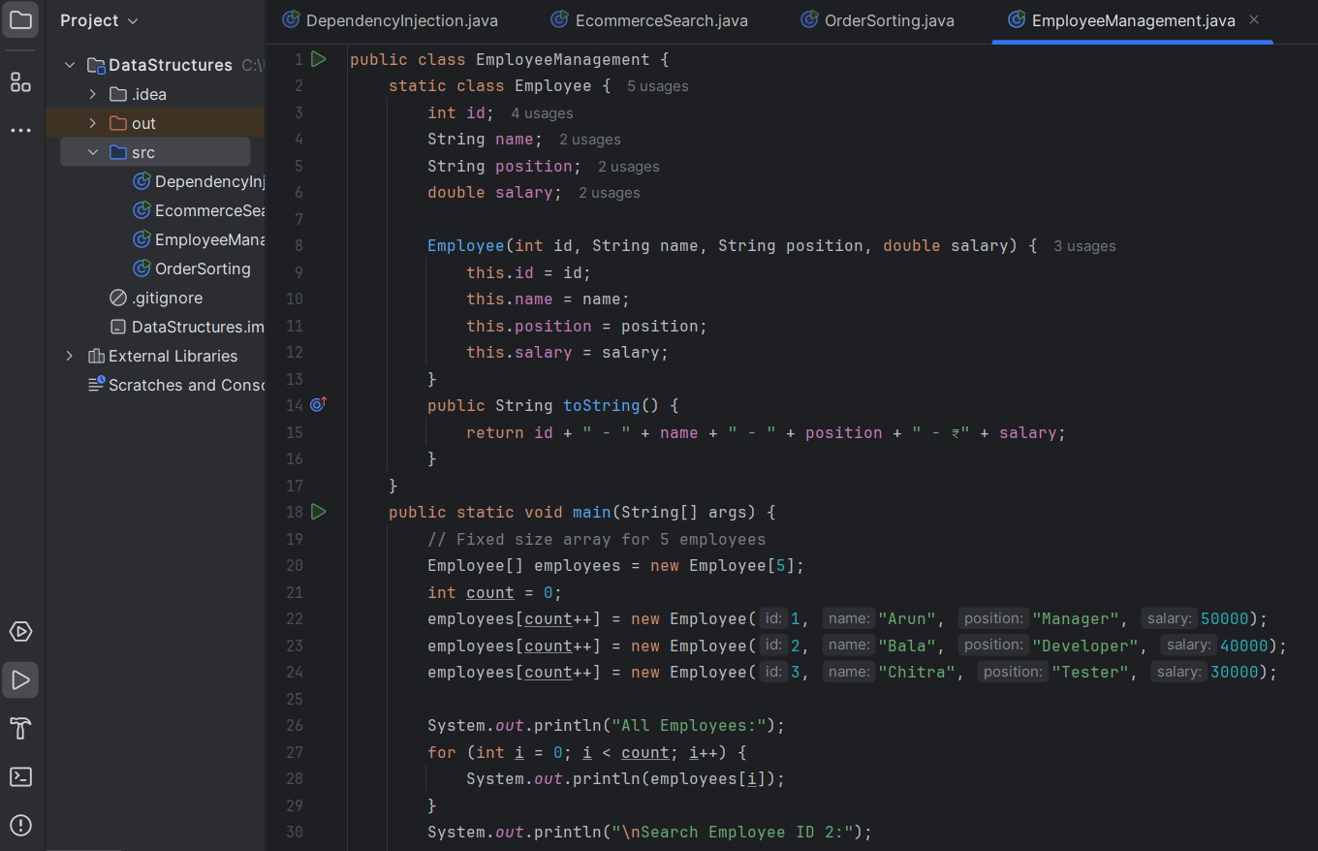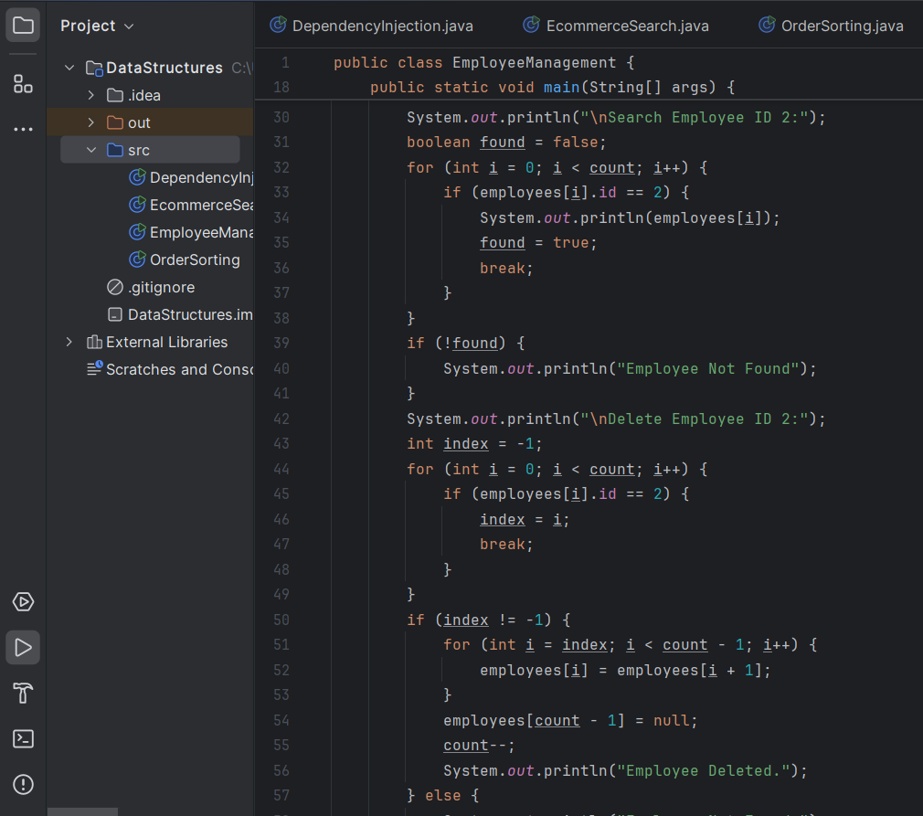 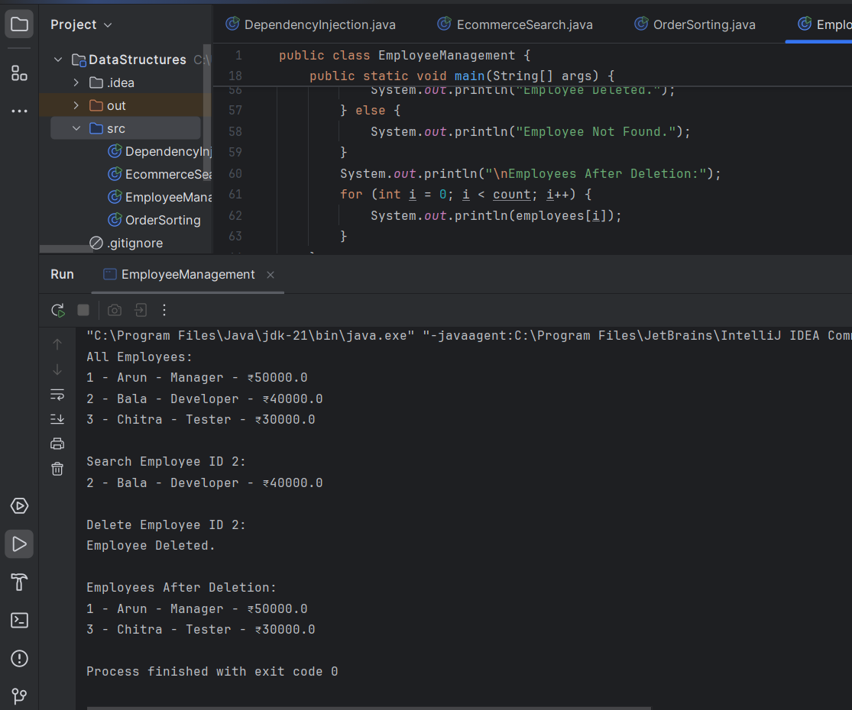

Exercise 5: Task Management System

Scenario: You are developing a task management system where tasks need to be added, deleted, and traversed efficiently.

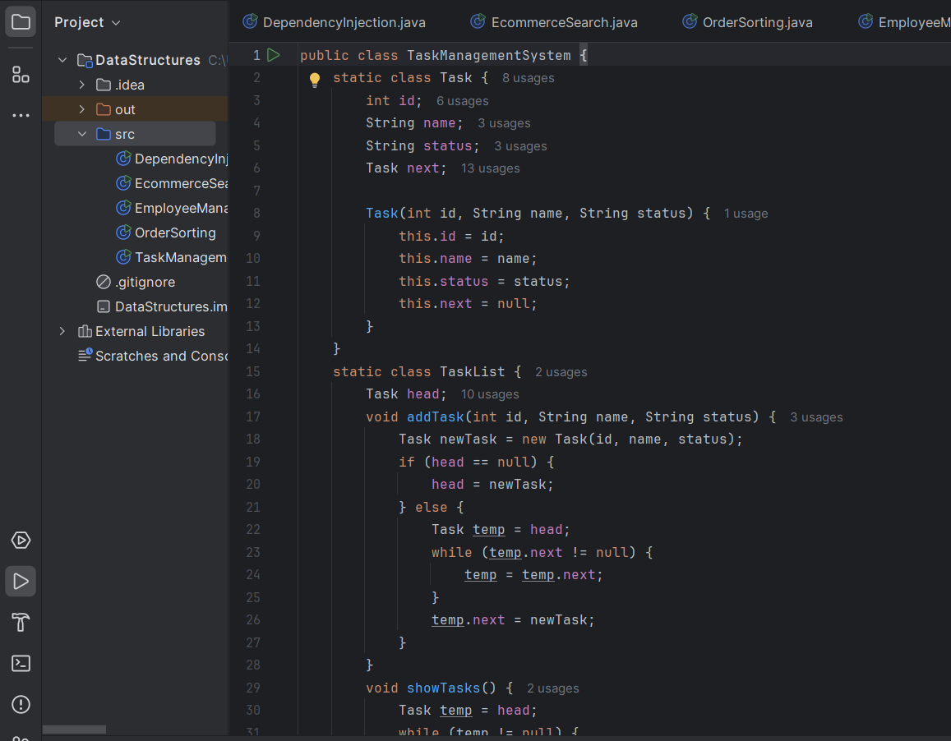

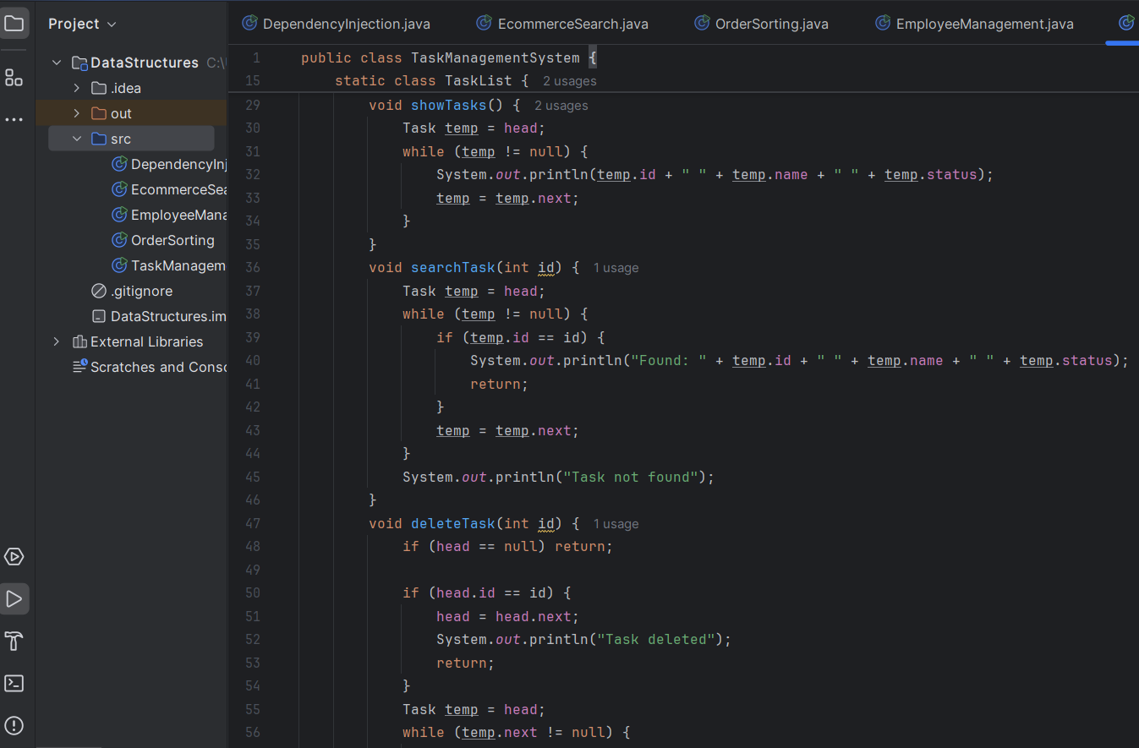

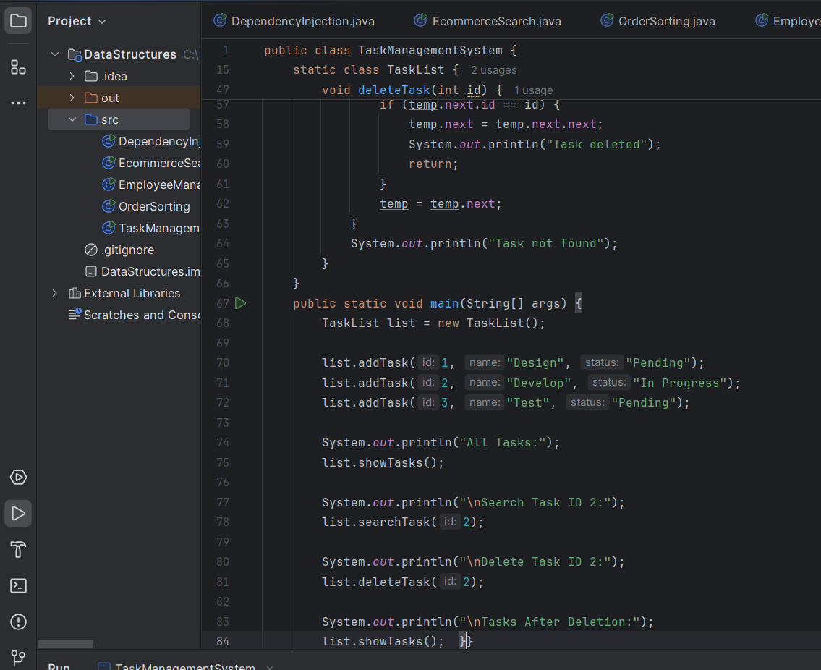

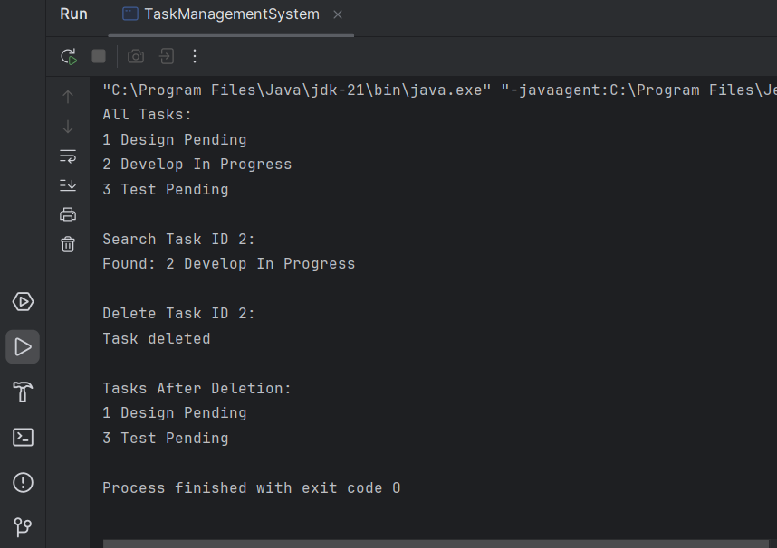

Exercise 6: Library Management System

Scenario: You are developing a library management system where users can search for books by title or author.

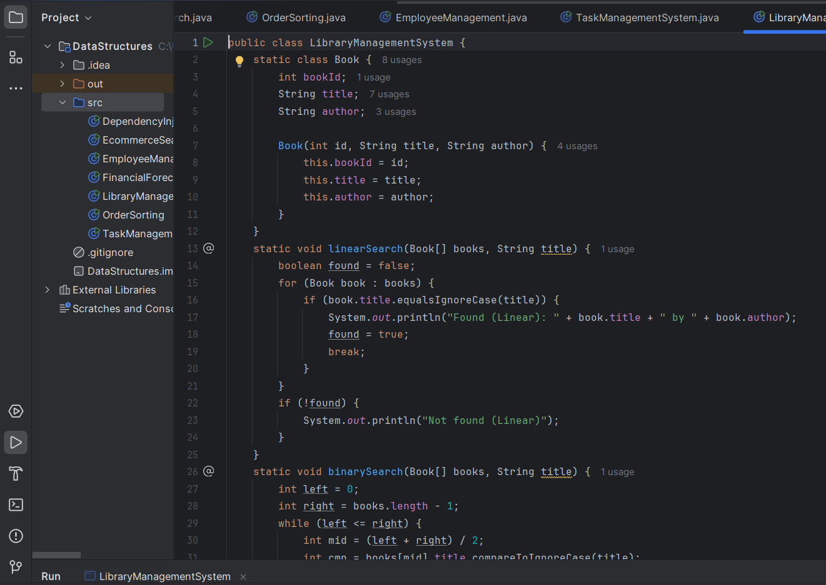

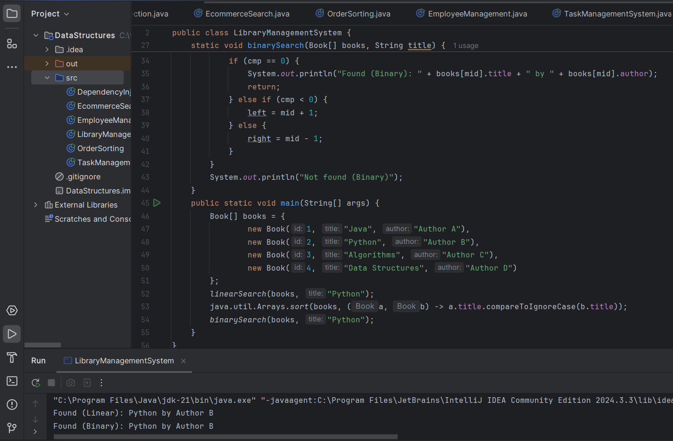

Exercise 7: Financial Forecasting

Scenario: You are developing a financial forecasting tool that predicts future values based on past data.

